Staff Dance
A comedy in Three Acts
by
Robert Morley

Performed by West Moors Drama Society - November 1961

Cast

Evelyn Watson.......................................................Helen Filcher
Telegraph Boy.......................................................John Lewis
Curzon....................................................................Nora Lewis
Charles Dermant...................................................Charles Frazer
Miriam Dermant.....................................................Katleen Short
Sir John Wilton.......................................................David Lewis
Frieda Appleby......................................................Joy Behennah
Samson Appleby...................................................Derek Collins
Felicity....................................................................Hazel Peters

Producer:................Frank Behennah

 | 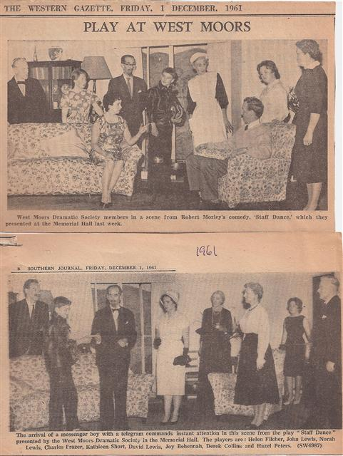 |  | 