The Chiltern Hundreds
by
William Douglas Home

Performed by West Moors Drama Society 19 - 21 November 1970

Cast
Earl of Lister................................................Leslie Saunders
Countess of Lister.......................................Mary Mosley
June Farrell..................................................Angela Carter
Bessie..........................................................Mary Talbot
Beecham.....................................................Derek Collins
Lord Pym.....................................................Hugh Wadsworth
Lady Caroline..............................................Maggie Adams
Mr Cleghorne...............................................Ken Mee

Producer..............................Sybil Rollings

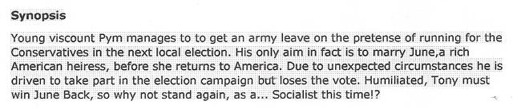

 | 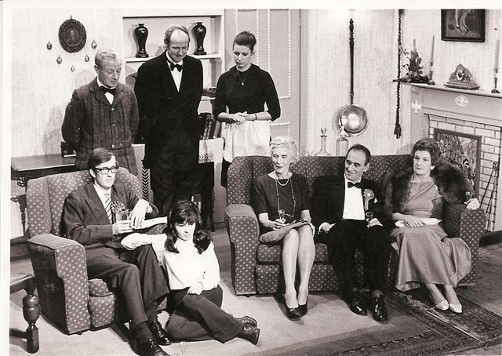 |  | 