Play Safe
A comedy in 2 acts

Written by: Jane Hilliard & Paul Rudelhoff

Performed by West Moors Drama Society 26 - 28 November 2015

The Cast

Florrie Fortuna.....................................Jeanie Ellis
Mavis Fulbright....................................Jane Hilliard
Matron...................................................Shelagh Rundle
Miriam Maplethorpe.............................Anne Maynard
Peter Legrand.......................................Alan Dester
Lance Kennedy.....................................Peter Wright
Lee.........................................................Alex Willmott
Ben........................................................Tom Clifford
Carina....................................................Joan Harrison
Charlie Chuckles..................................Derek Kearey
Barry......................................................Tom Martin

Directed by: Tom Martin.

Synopsis

Ex game show host Lance Kennedy and his wife run "Fairlawn", a small rest home for retired showbiz folk.
They are a slightly eccentric group of people still trying to re-live their days of fame on the small screen.

Florrie was once the presenter of a wild life show and Mavis played a nurse in a hospital drama. Together they cause mayhem as they search for animals and injured bodies.

Miriam solved crimes and knitted! Peter was a vicar in a soap opera but prefers to remember his days as a Shakespearian actor and never misses an opportunity to quote "Dear Willy".

Poor old ex-stand-up comedian Charlie Chuckles! No one seems to get his jokes and now he is just a grumpy old man who enjoys causing mischief.

Carina the hired help does her best to keep them all in order and Matron runs the home with a rod of iron. Their patience is severely tested with the arrival of the "Bentley Boys", two teenage mini crooks sent to the rest home to serve out their Community Service.

It is soon apparent that "The Boys" have an ulterior motive for being at the home. They are looking for something and they are not the only ones! Who will find it first?

Chaos and mayhem run riot in this world of "Dotty" entertainers and small time
Play Safe
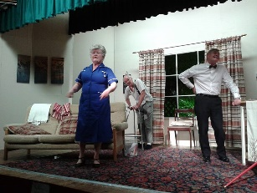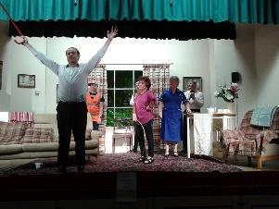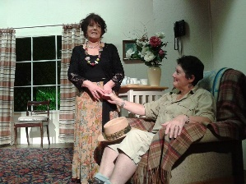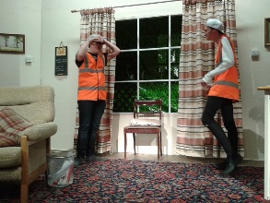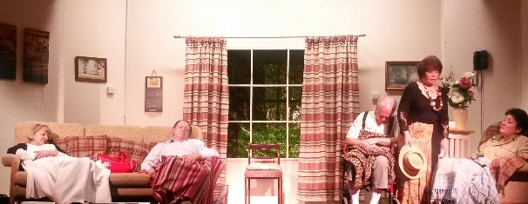
Reviews
By Stour & Avon Magazine | Posted: November 27, 2015
West Moors Drama chose a comedy for its latest production but not a familiar farce as this was written by experienced player and previous director Jane Hilliard, together with Paul A J Rudelhoff. They created a very funny play.
The action takes place in a home for retired entertainers (a splendid set which complemented the storyline) where the residents endeavour to relive their television roles. Into this world of eccentricity come a couple of likely lads on community service. They are not what they seem to be and pandemonium ensues as the story unfolds.
Fairlawn is run by Lance Kennedy who was previously a game-show host and Peter Wright does a good job with the part. Matron, his wife, is well characterised by Shelagh Rundle with the forceful voice and persona of a real battle-axe. Completing the staff is domestic help Carina and Joan Harrison impresses as she cleverly makes this pivotal role her own.
Miriam Maplethorpe, previously a television detective, is ideal for Anne Maynard who is delightfully dotty. She is a perfect foil for Peter Legrand – the capable Alan Dester – who recalls his career as a Shakespearean actor and quotes the Bard at every opportunity. Another resident remembering his glory days is Charlie Chuckles (West Moors Drama stalwart Derek Kearey) and his first appearance unclothed except for a blanket brings the house down.
Neither Florrie Fortuna – Jeanie Ellis is admirable – or Mavis Fulbright (the multi -talented Jane Hilliard) are as mad as they originally seem, revealing secrets as the plot thickens. Teenage brothers Ben - well played by Alex Willmott - and Lee (Tom Clifford shows promise) are not in Fairlawn to pay their debt to society and the boys are vital to the intrigue. This pair are making their debuts with the group and will, hopefully, continue to gain confidence and learn from experienced actors.
Tom Martin directed and produced, he must be congratulated for keeping up a fast pace and using the cast to their best advantage. Also taking the cameo role of Barry the Brain, he epitomises the spirit of amateur theatre so look out for West Moors Drama productions in the future.
Play Safe continues until Saturday, there may be a few tickets left but don’t delay if you want to see an original comedy.
By Pat Scott

