Dear Charles
by
Alan Melville

Performed by West Moors Drama Society 30 April, 1 & 2 May 1981

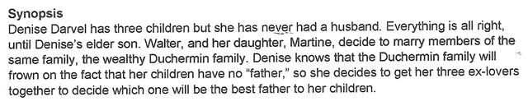

Cast
Martha......................................................Maggie Adams
Edward....................................................George Turnbull
Walter.......................................................Mike Hutchings
Bruno........................................................Roger Bosher
Denise Darvel.........................................Suzanne Eames
Martine.....................................................Jane Hilliard
Sir Michael Anstruther............................Leslie Saunders
Jan Letzaresco........................................Peter Foster
Dominique Lecler....................................Derek Collins
Madame Duchemin.................................Mary Mosley
Lucienne...................................................Heather Collins
Jean-Pierre..............................................Baird Oldrey

Director.........................Frank Behennah

