On The Verge
a comedy by Peter Horsler

Performed by West Moors Drama Society 19 - 21 November 1987

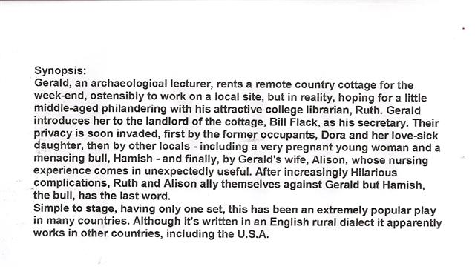

Cast
Bill Flack.............................................................Mark Austin
Dora Day............................................................Jane Hilliard
Teresa Day........................................................Amanda Underhill
Lily Flack............................................................Sue Taylor
Gerald Turner....................................................John Norman
Lionel Flack........................................................Jon Row
Ruth Hill..............................................................Michele Behennah
Debbie Martin....................................................Anne Baker
Tom Day.............................................................Jim Orman
Alison Taylor.....................................................Cyndy Halls

Producer..................Frank Behennah

