Drinking Habits
by
Tom Smith

Performed by West Moors Drama Society 13 - 15 November 2014

 | The Cast  Sister Philomena.........Ellie Tripp  Sister Augusta............Shelagh Rundle  George.......................Derek Kearey  Mother Superior..........Caroline Burr  Paul...........................Alan Dester  Sally..........................Kirsty Dixon  Sister Mary Catherine.Jilly Jackson  Father Chenille...........Tom Martin  Director......................Jane Hilliard  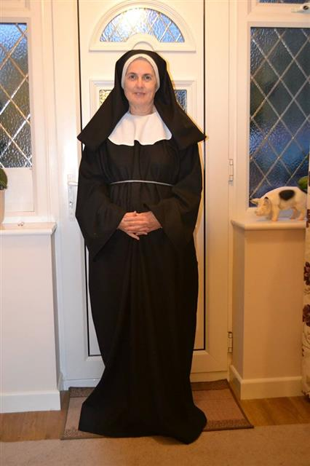 |  | Synopsis  Two Nuns at the "Sisters of Perpetual Sewing" have been secretly making wine to keep the convent's doors open, but Paul and Sally, reporters and former fiancees are hot on their trail. They go undercover as a nun and priest, but their presence combined with the addition of a new nun spure paranoia throughout the convent that Rome has sent spies to shut them down.  Wine and secrets have inevitably spilled as everyone tries to preserve the convent and reconnect with lost loves.  Reviews  