The Booby Trap (2016 Production)

By Jane Hilliard

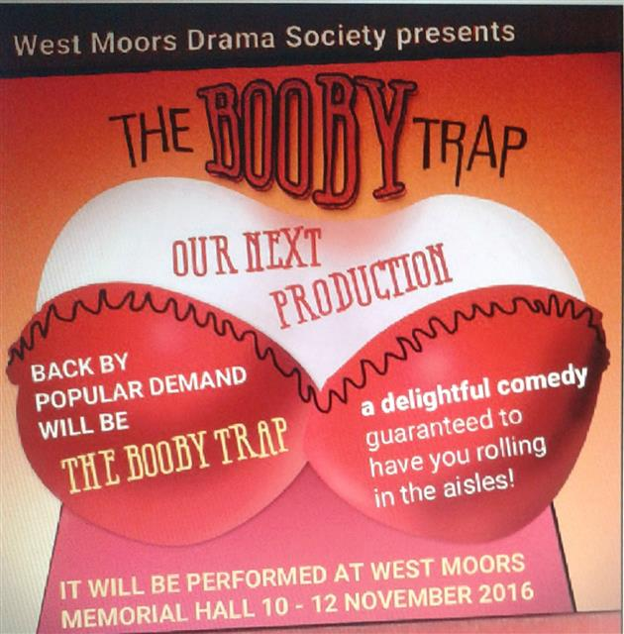

Cast:

Gerald Caunfield MP Alan Dester
Debbie Caunfield Anne Maynard
Flora Faustine Robert
Chrissie Kristy Lenore
Sam Alex Wilmott
Clara Joan Harrison
Margery Shelagh Rundle
Cyril Derek Kearey

Producer: Jane Hiliard Director: Tom Martin

This play was first produced by West Moors Drama in 2005.

