West Moors Drama Society
Presents
Grandma’s Secret
By Jane Hilliard & Paul Rudelhoff
29,30 November & 1 December 2018

Cast
Chris Tom Clifford
Mavis Davis Anne Maynard
Hilda Makepeace Jeanie Ellis
Harry Tom Martin
Mrs Clapstick Jane Hilliard
Sarah Denise Hennessey
Mr Wagstaff Alan Dester
Tarquin Stubbs Derek Kearey
Carina Julia Garmin
Esme Rosemary Worsley

Producers & Directors
Jane Hilliard & Paul Rudelhoff.
Synopsis
Grandma Mavis Davis has been safely packed off in a taxi to spend Christmas in a nursing home – or so the family thinks. But Mavis and her two friends Hilda & Harry have other plans. They have important things to attend to and do not want any distractions.
While his grandmas is supposedly away, Mavis’ grandson Chris thinks that with the house is now empty he has a wonderful opportunity to invite a few of his friends round for a party.
After Mavis discovers Chris she realises that his presence at her house is going to interfere with their plans so she, Hilda and Harry have to decide what to do with him.
While they are trying to work that out, the arrival of several unwanted guests just adds to their problems. How will they cope? Wil the “tickly feather thingies” arrive in time? And who is the mysterious Ms Dias Viva?

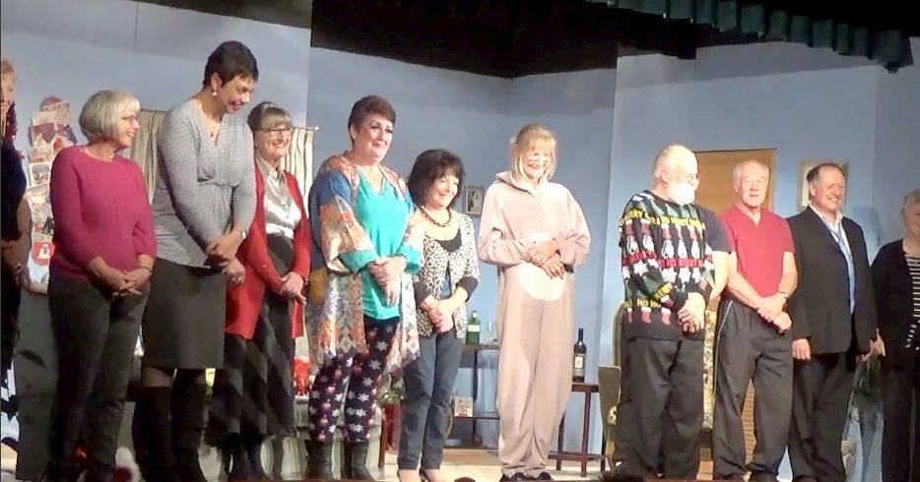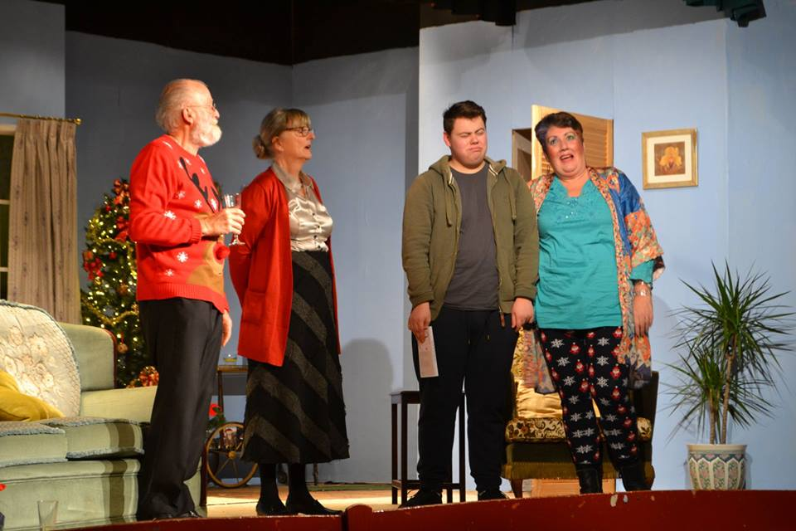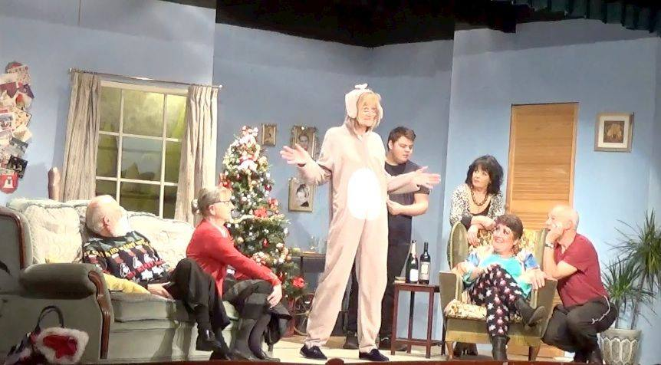
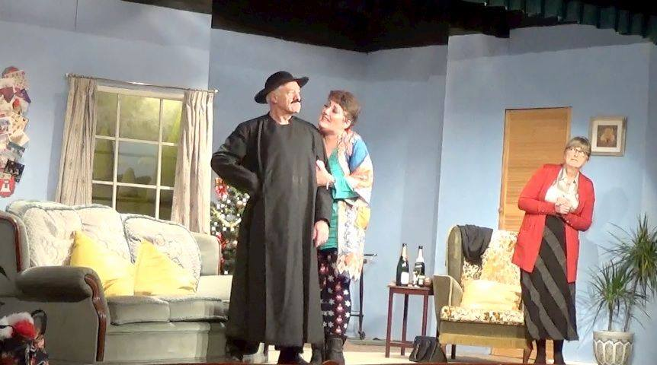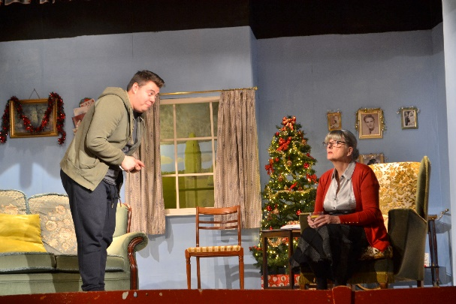

GRANDMA’S SECRET

Review
- : West Moors Drama Society: West Moors Memorial Hall, West Moors Philip & Julie McStraw : 1 December 2018
The splendid West Moors Drama Society is a local institution. It has been presenting grassroots theatre productions since 1957, mostly performing light comedies and occasionally serious plays. Each year the Society normally puts on two productions and continues this tradition with the new play Grandma’s Secret, written and directed by talented local playwrights Jane Hilliard and Paul A J Rudelhoff.
This enjoyable play has all the hall marks of the time honoured “Farce” – stereotyped characters, making use of exaggerated and improbable situations with a generous helping of silliness – all designed to be entertaining and make the audience laugh!
A certain Mavis Davis is the Grandma with a secret who, with the help of her friends Hilda and Harry, has been writing bestselling books in the style of 50 Shades of Grey under the assumed name of M S Dias Viva (an anagram of Mavis Davis). So far she has managed to hide her identity from her family and the public. Mavis is now writing her very last book and with the deadline approaching she needs to be in her own home putting the finishing touches to the final chapter. Her family, however, have other ideas and have arranged for her to go into a nursing home for the Christmas period whilst they are on holiday. Mavis hatches a plan to send her somewhat batty and forgetful friend Esme to the nursing home in her place. Hilda and Harry arrive to assist with the writing and testing of the adult toys that feature in the books, but their plans are thwarted as Mavis’ grandson has turned up at the house thinking it will be empty and planning a party for his mates. To add to her problems, someone has leaked her address to the press and a journalist is on the way to expose Mavis and her double life. As if this wasn’t enough to be going on with, her sister turns up with estate agent Roland Wagstaff and a burglar also puts in an appearance – known locally as the ‘wrinkly burglar’ owing to his advancing years, and a modus operandi involving cooking himself a good meal rather than removing items of value!
The results, which are predicable in the way that farce is meant to be, were satisfyingly funny and amusing from beginning to end. The performance romped along at a fair pace and for the most part the timing and dialogue flowed well, with few hesitations when a line was momentarily forgotten. Not that this really mattered to an audience that was fully engaged in the performance with laughter aplenty at every innuendo, double entendre and the malapropisms of Hilda, (well played by Jeanie Ellis). A good laugh was also had at the expense of Roland Wagstaff (and a fine acting performance from Alan Dester) who suffered from the unfortunate effects of rhotacism and his pronunciation of the “r” sound as a “w”. Anne Maynard, playing the main character Mavis, produced a convincing performance of a likeable character that would not be dictated to by her insensitive family. Tom Clifford came into his own as the “fruity” Peaches Delmonte, though initially perhaps not quite as much at ease playing the grandson Chris. Tom Martin, playing Harry, and Jane Hilliard as nosey neighbour Mrs Clapstick turned in pretty solid support performances, as did the rest of the cast.
The production and backroom team as a whole are to be congratulated for building an authentic set on a relatively small stage with sufficient room for the actors to move around in, and for the proficient management of the sound and lighting.

