Poison Pen
by
Richard Llewellyn
Performed by West Moors Drama Society 20 - 22 November 1980

Cast

Rev John Rainrider...........................................Peter Foster
Phryne Rainrider...............................................Suzanne Eames
Rose Rainrider..................................................Michelle Bosher
Mrs Harboard....................................................Maggie Adams
Badham.............................................................Leslie Saunders
Malcolm McCleod............................................ Keith Chauncy
Colonel Cashelton............................................Bill Thoroughgood
Mrs Cashelton...................................................Mary Mosley
Inspector Colclough..........................................George Turnbull
Mrs Colclough...................................................Margaret Walter
Mr Fullergrave Rees........................................ Mike Hutchings
Sam Hurrin........................................................Derek Collins
Len Griffin..........................................................Roger Bosher
Connie Fately...................................................Jane Hilliard
Mrs Reynolds....................................................Sylvia Strickland
Mrs Scaife.........................................................Briony Vincent

Director.........................Frank Behennah

Synopsis
Poison Pen is a dark and depressing look at the turmoil faced by an already gossip ridden village when one of its own resorts to slander of the most vicious kind in order to compensate for the lack of normalcy in his or her own life. Reginald Tate is excellent as the righteously indignant ...

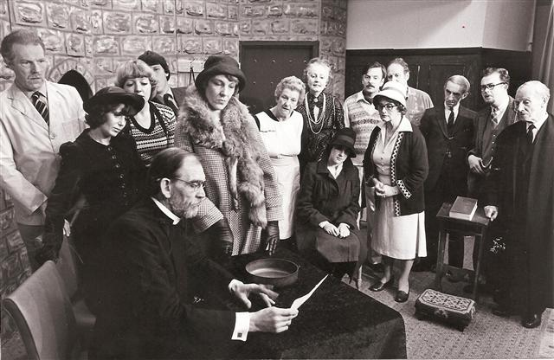

 | 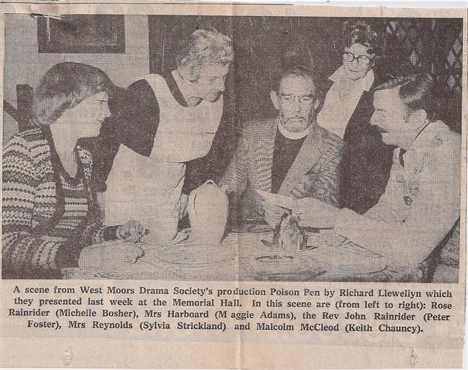 |  | 