Out of Order
by
Ray Cooney

Performed by West Moors Drama Society 23 - 25 November 2000

Synopsis
When Richard Willey, a Government Junior Minister plans to spend the evening with Jane Worthington, one of the Opposition's typists, things go disastrously wrong, beginning with the discovery of a body trapped in the hotel's only unreliable sash window. Desperately trying to get out of an extremely sticky situation, Richard calls for his PPS, George Pigden, who, through Richard's lies, sinks further and further into trouble with everybody and ends up going through an identity crisis. Things go from bad to worse with the arrival of Ronnie, Jane's distraught husband, and with the addition of an unscrupulous waiter, Mrs Willey and Nurse Foster things really come to a head....

 | 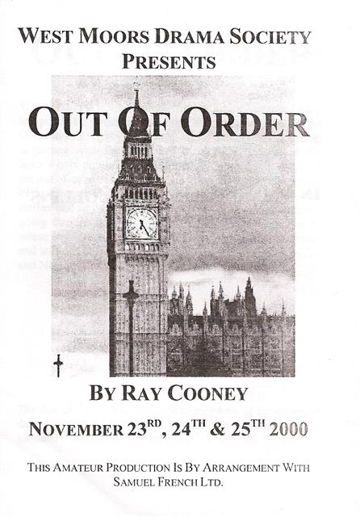 |  | Cast  Richard Willey....................... Mark Austin  TheManager.......................... Ian Campbell  Jane Worthington.................. Emma Sargeant  A Body................................... Dave Hughes  The Waiter............................. John Norman  George Pigden....................... Phil Bowditch  The Maid................................. Claire Rundle  Ronnie Worthington................ Rob Baker  Pamela Willey......................... Elise Scott  Gladys..................................... Linda Campbell  Director  John Norman  