Outward Bound
by
Sutton Vane

Performed by West Moors Drama Society - 6 - 8 December 1984

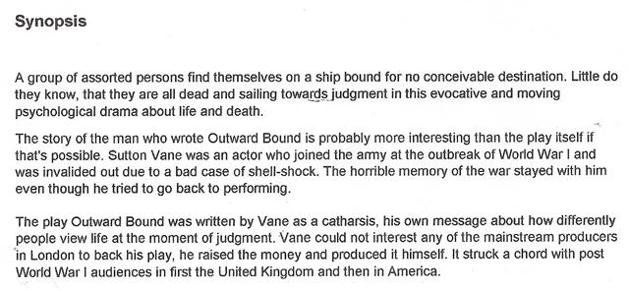

Cast

Scrubby...............................................................John Norman
Ann.......................................................................Michele Behennah
Henry....................................................................Phil Bowditch
Mr Prior............................................................... .Robert Nicholson
Mrs Clivedon-Banks........................................... Tess Campbell
Rev William Duke.............................................. ..Leslie Saunders
Mrs Midget........................................................ ...Suzanne Eames
Mr Lingley.............................................................Bill Thoroughgood
Rev Frank Thomson......................................... ...Frank Behennah

Director.............................George Turnbull

