The Gift
by
Mary Lumsden

Performed by West Moors Drama Society - 25 - 27 November 1965

Cast

Miss Hooper..................................................Patricia Driscoll
Mrs Saunders................................................Kathleen Short
Justin Allister.................................................Derek Collins
Julie Dennison..............................................Joy Behennah
Lady Elizabeth Crossley...............................Barbara Cheyne
Sir David Crossley........................................Kenneth Cheyne

Producer..........................Joan Stewart

 | 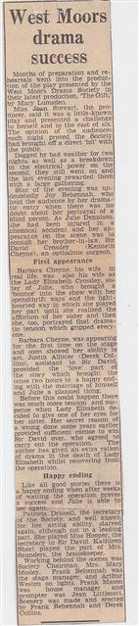 |  | 