DI Why?

A comedy by Ian Hornby
Performed by West Moors Drama Society
28 - 30 November 2013

Synopsis:

Sara is not very happy when her husband Paul asks his friend Tim "the handyman from hell" to help with some electrical work. Tim would do anything for Sara, anything.
After burst pipes, floods, failed heating, power cuts and other disasters Tim gets his marching orders, but not before he finds out Sara's feelings for him. Doors and windows nailed shut, a smell of gass... all the ingredients of a DIY farce.

 | The Cast  Frank.................. Derek Kearey  Paul.....................Alan Dester  Sara....................Jane Hilliard  Kathleen..............Shelagh Rundle  Barbara................Anne Maynard  Tim......................Peter Wright  June.....................Debbie Butterworth  Director/Producer: Tom Martin.  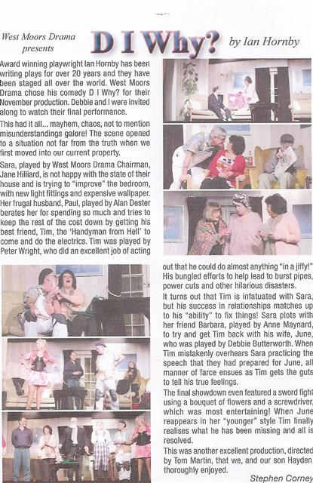 |  | 