Strangers in the House
by
Victor Lucas

Performed by West Moors Drama Society 4 - 6 May 1972

Cast

Mrs Benbow........................................................Maggie Adams
Mrs Jones............................................................Mary Mosley
Mr Jones..............................................................Leslie Saunders
Penny Jones........................................................Elizabeth Jones
Cyril Jones...........................................................Michael Hutchings
Miss Chambers...................................................Jacquie Longman
Miss Fairfax..........................................................Barbara Amery
John Cunningham................................................Hugh Wadsworth
Arabella Bunter-Cutts....................................... ...Anne Mosley

Director......................Kenneth Mee

Synopsis
Strange, but very funny happenings, are occurring at the faded and eerie manor of Creeching Cheyney. An oddly assorted group of people are assembled on a snowy Christmas Eve to hear the reading of a will laying down certain stipulations before they can inherit their legacies. A creepy butler, who is…

 | 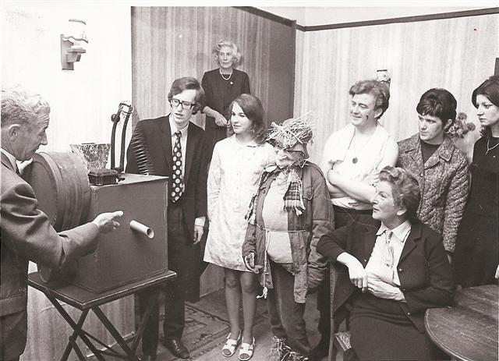  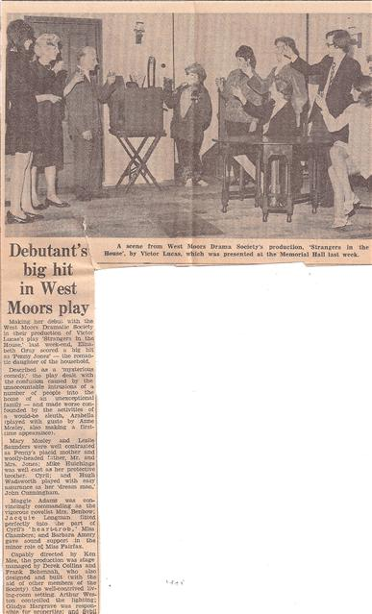 |  | 