The Bride Comes Back
by
Ronald Miller

Performed by West Moors Drama Society 24 - 26 April 1975

Cast

Barbara Kilpatrick.............................................Mary Talbot
Mrs Gow...........................................................Ray Dix
Jason Kilpatrick................................................Leslie Saunders
Isabe Kilpatrick................................................Sybil Rollings
Serena Tilney...................................................Liz Thomas
Smith................................................................Peter Foster
A Young Woman..............................................Lorraine McKillop
Joe Tilney.........................................................Mike Hutchings

Director............................Derek Collins

A sequel to “The Bride and the Batchelor “ performed by WMDS in 1973

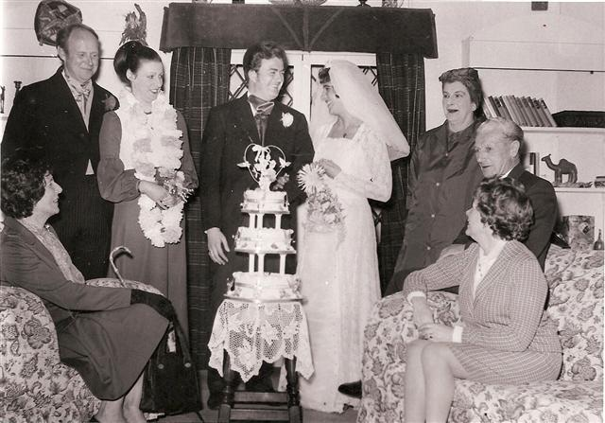

 | 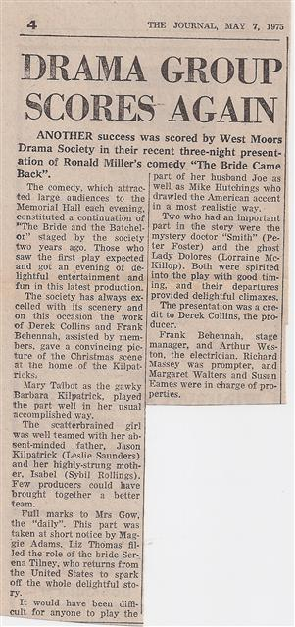 |  | 