Tiptoe Through the Tombstones
by Norman Robbins

Performed by West Moors Drama Society - February 2004
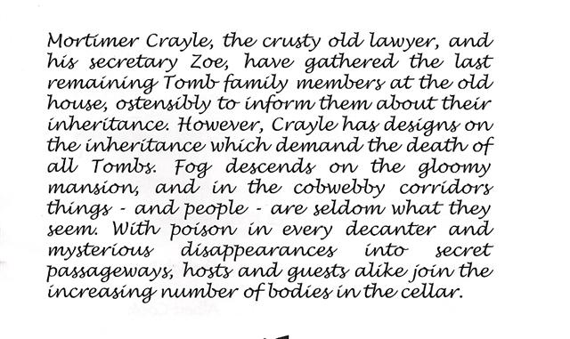

Cast
Vernon.....................................................Rob Baker
Edna........................................................Sarah Stafford
Fabia.......................................................Jane Hilliard
Augusta....................................................Shelly Seager
Henrietta..................................................Shelagh Rundle
Crayle.......................................................Albert Cook
Larry.........................................................Dan Sheen
Octavia.....................................................Hazel ter Pooten
Athene.....................................................Janet Price
Zoe...........................................................Jeanie Ellis

Directors
Jane Hilliard & Shelly Seager

Critique
