West Moors Drama Society
Presents

See How They Run
A farce by Philip King

Performed at the Memorial Hall 18-20 April 1985

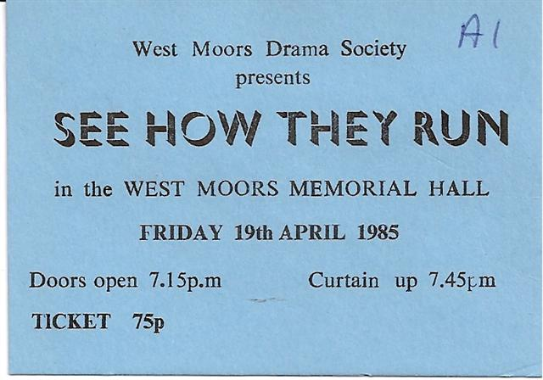

Synopsis
here's nothing remotely Christmassy about Philip King'swartime farce See How They Run but, as festive fare goes, it's a cracker. It's not just the mistaken identities – though there's plenty of scope for that with five dog-collared clerics (of whom only three are the real thing) – or the ludicrous, fast-paced plot, ...

 | Cast  Ida -a maid..................Eunice Clayton-Paine  Miss Skillon................Diana Champ  Rev. Lionel Troop.. ...Robert Nicholson  Penelope Troop..... ...Barbara Wilson  L/Cpl Clive Winton... .Mark Austin  The Intruder................John Norman  Bishop of Lax.............Les Saunders  Rev Arthur Humphrey... ..George Turnbull  Sgt. Towers................Bill Thoroughgood  Director  Derek Collins  The Set Builder's Lament...  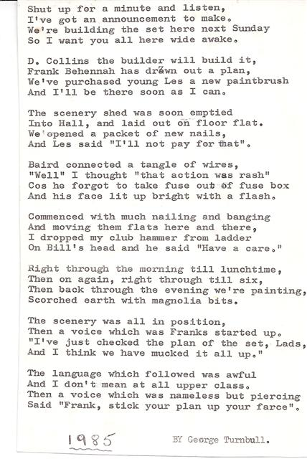 |  | 