Pull the Other One
A Farce by Norman Robbins

Performed by West Moors Drama Society - 23 - 25 April 1998

Cast

Boadicea Heptinstall....................................... Linda Campbell
Wilf Turner........................................................John Norman
Muriel Perkins..................................................Janet Rushton
Albert Perkins...................................................Mark Austin
Virginia Brown..................................................Trish Binding
Hilary Armitage.................................................Ian Campbell
Rev. Elijah Nookey...........................................Baird Oldrey

Director
Sue Oldrey
Synopsis.

Albert Perkins is blessed with a loving wife, Muriel, and cursed with a fearsome mother-in-law, Boadicea. When his good friend Hilary Armitage writes to him reminiscing about the good times they used to have, Boadicea reads the letter and determines to remove her daughter instantly from the clutches of this ...

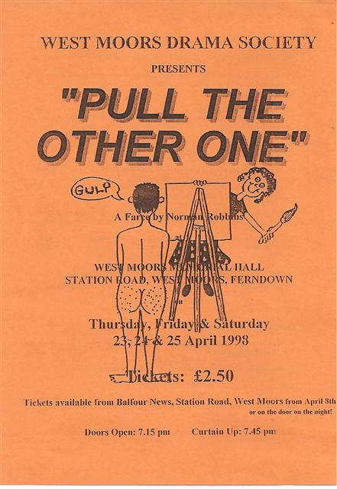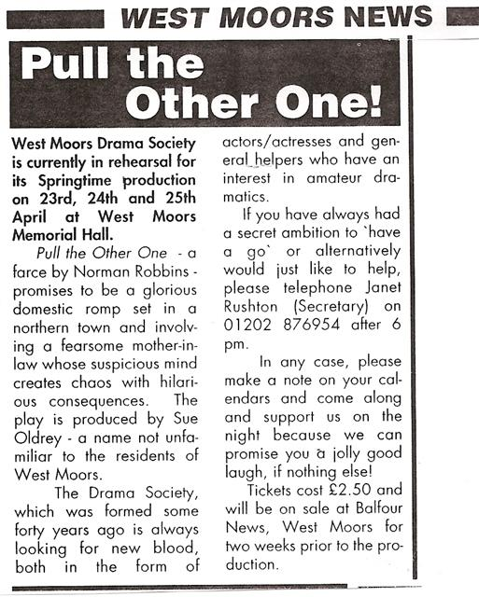

Pull the Other One

