Theatre of War

A village recruiting scene during First World War
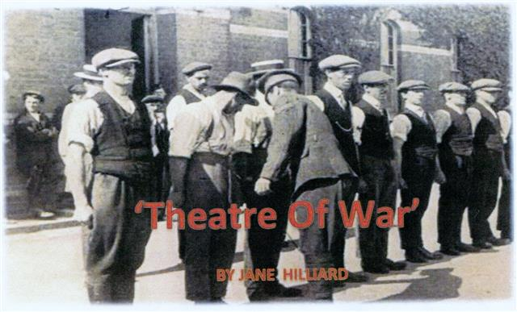
Synopsis

1914, the outbreak of 'The Great War'

The inhabitants of a sleepy English village struggle to come to terms with the changes in their lives now that the able-bodied men have left to defend their country. Those that are left behind continue with steely determination to keep the village as it was for their loved ones' return.
Sadly, the futility of war touches them all.

This 30 minute production was written and Produced by Jane Hilliard at the request of the Memorial Hall management to be performed as part of the Hall's re-dedication event on 16th August
The Cast

Dolly...................Rosemary Worsley
Mrs Brewster.......Jeanie Ellis
Frank...................Derek Kearey
Mary....................Jane Hilliard
Gladys.................Shelagh Rundle
Edna....................Shelly Seager
Nurse...................Jill Jackson
Delphinia..............Janet Price
Caleb...................Tom Martin
Vicar....................John Price
Captain Smythe.... Peter Wright
Modern Soldier.......Alan Dester

