Where There's a Will
by
Norman Robbins

Performed by West Moors Drama Society - 30 April 1&2 May 2009

Cast

Genista Royal.........................................Janet Price
Fordyce Newton......................................Mark Austin
Velma Newton.........................................Beverley Cooper
Miriam Holt.......................................... ...Jane Hilliard
Rev Arthur Peasegood....................... ....Tom Martin
Bella Moore.............................................Jeanie Ellis
Cissie Cunningham.................................Eileen Paddick
Donna Moore..........................................Hannah Lloyd-Williams
Troy Jarvis..............................................Blair Fergie

Director......................Paul Rudelhoff

 | Synopsis  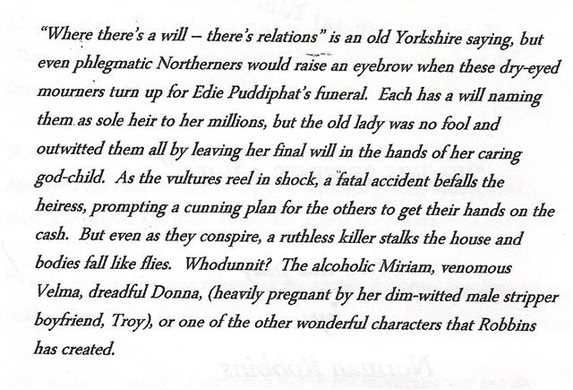 |  | 