Habeas Corpus
by Alan Bennett

Performed by West Moors Drama Society 29-30 November 1996

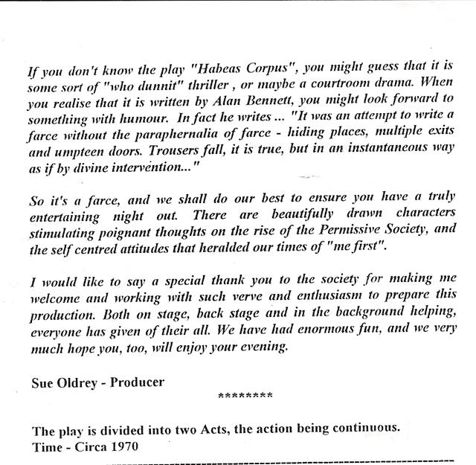

Cast

Arthur Wicksteed...................................Ian Campbell
Muriel Wicksteed..................................Sara Corfield
Dennis Wicksteed..................................Rob Baker
Constance Wicksteed............................Janet Rushton
Mrs Swabb.............................................Hayley Lord
Canon Throbbng....................................Rod Chapman
Lady Rimpers........................................Shelagh Rundle
Felicity Rumpers....................................Elise Hawkes
Mr Shanks.............................................John Norman
Sir Percy Shorter...................................Baird Oldrey
Mr Purdue..............................................Rob Lord

Director
Sue Oldrey

