Laburnum Grove
by
J B Priestley

Performed by West Moors Drama Society -23-25 April 1964

Cast

Elsie Radfern....................................................Pamela White
Mrs (Lucy) Baxley.............................................Patricia Driscoll
Bernard Baxley.................................................Stuart Matheson
George Radfern................................................Leslie Saunders
Harold Russ.......................................................Derek Collins
Joe Fletten.........................................................George Ashton
Mrs (Dorothy) Radfern......................................Kathleen Short
Inspector Stack..................................................Kenneth Cheyne
Sergeant Morris.................................................Douglas Edroff

Producer...................Frank Behennah
Synopsis

George Radfern lives a quiet, uneventful life near London, burdened by sponging relatives and his prospective son-in-law. When George quietly announces he's a leader of a counterfeit ring, the sponges find reasons to leave. His immediate family reacts according to character until it looks ...

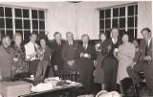

 | 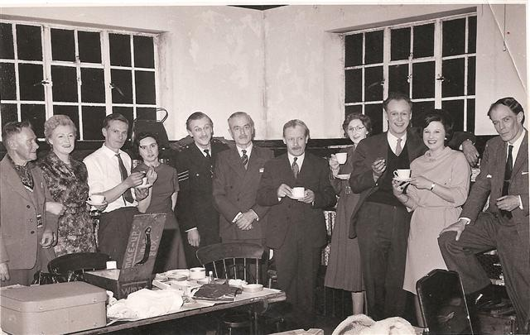 |  | 