John Marlow's Profession
by
Wilfred Massey

The second production of West Moors Drama Society - April 1957

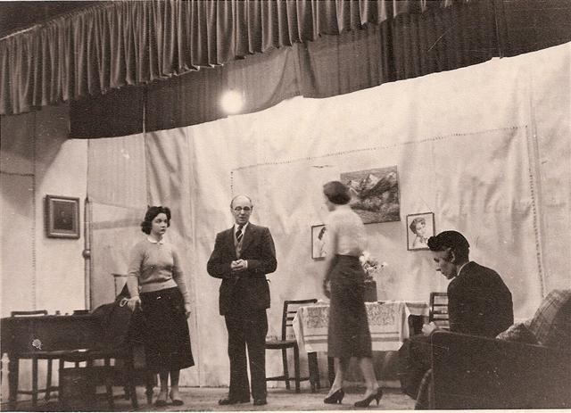

This is the only information currently available about this production. It is clearly in the West Moors Memorial Hall. It is the earliest picture in the archives of any Drama Society production, the Society being formed the previous year. If anyone has any further Information please let us know!
Some details of the play can be found on this website

